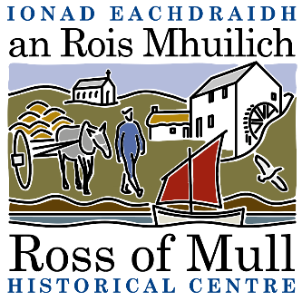

Millbrae Cottage, Bunessan, Eilean Mhuile, ARGYLL, PA67 6DG 01681 700 659 E: enquiries@romhc.org.uk

SCIO No: SC 030873
Ionad Eachdraidh an Rois Mhuilich
Ross of Mull Historical Centre

Agenda for 2021 Annual General Meeting

To be held on Thursday 27th January 2022 at 7.30 pm
by Zoom

1. Present

2. Apologies

3. Report from the 2020 AGM held by email

4. Trustees Report - attached

5. Approval of Financial Statements – Accounts attached

6. Election of Directors
Current Trustees are Anne Baxter, Sue Clare, Judy Gibson, Roger Harvey, Tessa Howell, Jan Sutch Pickard. At the AGM under SCIO, all are required to stand down, but all can be reappointed at this meeting.

7. AOCB

