Ionad Eachdraidh an Rois Mhuilich
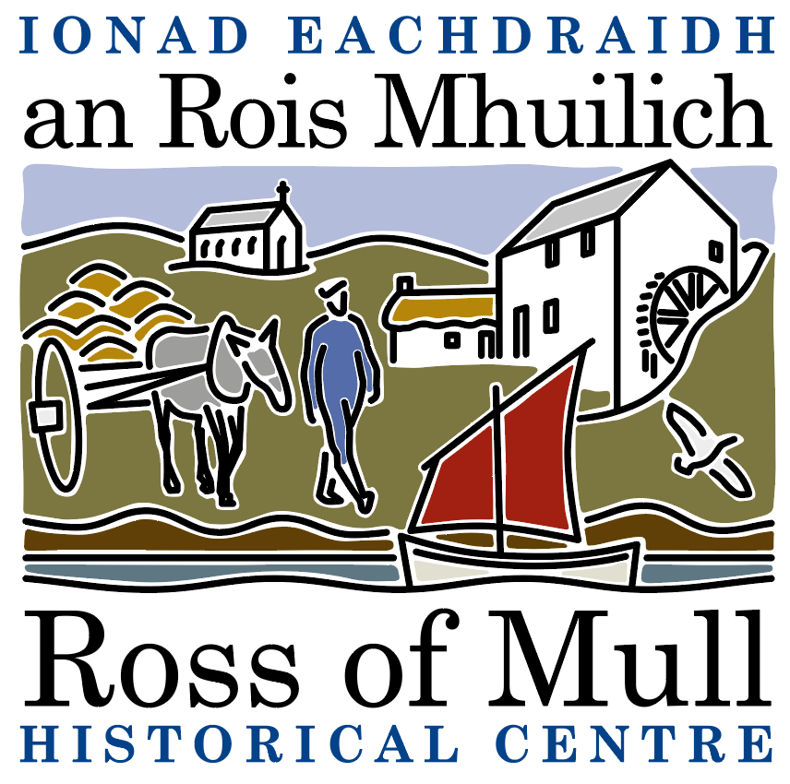

Millbrae Cottage, Bunessan, Eilean Mhuile, ARGYLL, PA67 6DG 01681 700 659 E: enquiries@romhc.org.uk

SCIO No: SC 030873
Ross of Mull Historical Centre

Agenda for 2022 Annual General Meeting

To be held on Saturday 14th January, 2023 at 2.00 pm
at the Ross of Mull Historical Centre, Millbrae Cottage, Bunessan

1. Present

2. Apologies

3. Report from the 2021 AGM held by zoom

4. Trustees Report

5. Approval of Financial Statements

6. Membership and Subscriptions

7. Election of Directors
Current Trustees are Anne Baxter, Sue Clare, Judy Gibson, Roger Harvey, Tessa Howell, Jan Sutch Pickard. At the AGM under SCIO, all are required to stand down, but all can be re appointed at this meeting.

8. AOCB

To be followed by a presentation by Iona artist Mhairi Killin who will talk about her recent collaborative project, On Sonorous Seas, which began when a whale carcass washed ashore on Iona in 2018. It is a story told with the voices of science, art, music and poetry, and it explores the impact of military sonar on the ecology of the seas surrounding the Hebrides.

