Ionad Eachdraidh an Rois Mhuilich
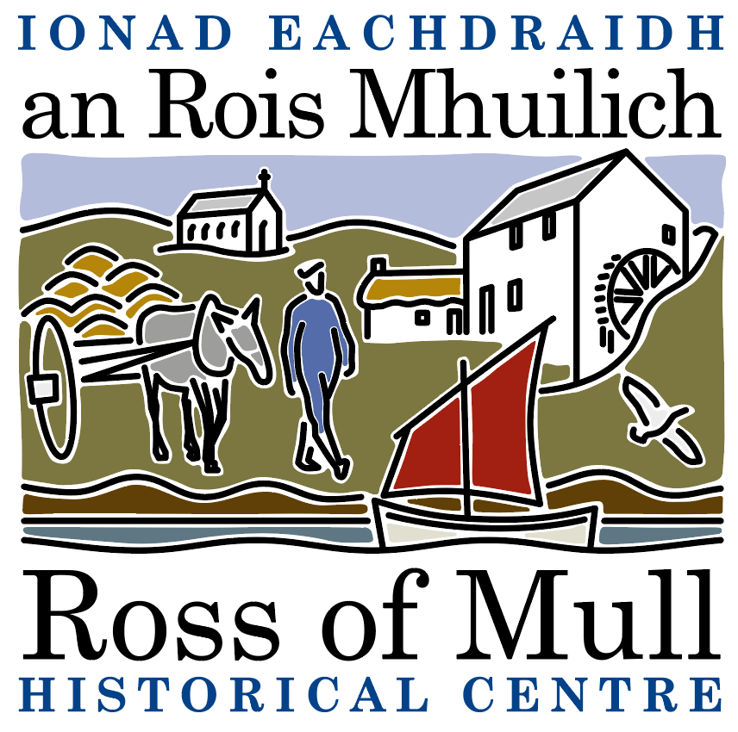

Millbrae Cottage, Bunessan, Eilean Mhuile, ARGYLL, PA67 6DG 01681 700 659 E: enquiries@romhc.org.uk

SCIO No: SC 030873
Ross of Mull Historical Centre
Minutes of 2021 Annual General Meeting

Held on Thursday 27th January, 2022 at 7.30 pm
by Zoom

1. Present
Anne Baxter, Nigel Burgess, Rosie Burgess, Andrea Cameron, Sue Clare (minutes), Judy Gibson (Chair), Roger Harvey, Tessa Howell, Kirsty Lord, Gillian Morley, Jan Sutch Pickard, Emily Wilkins.

2. Apologies
Jane Brunton, Sandy Brunton, Iain Howell, John Jervoise.

3. Report from the 2020 AGM
This was held by email, with members being sent the Minutes of the 2019 AGM, Accounts and Trustees Report for 2020. There were 19 responses. Members were asked to vote on three items:-
1. Approval of the minutes of the 2019 AGM - 17 approved and 2 abstained
2. Approval of the 2020 accounts - 19 approved
3. Re election of the Board of Trustees - 18 approved and 1 abstained

Approval of the report of the 2020 AGM was proposed by Rosie Burgess, seconded by Roger Harvey.

4. Trustees Report
Jan Sutch Pickard talked through the Trustees Annual Report Autumn 2021, which had been emailed to Members prior to the meeting, and is included with these minutes.
Even with the pandemic, it has still been an active year. Our limited opening, with covid safeguards in place, brought 110 visitors through our doors, interested in what we had to offer. As detailed in the Report, we have continued to offer our genealogy service for online enquiries, online sales have continued via our website, our website and e newsletters have kept people well informed, thanks to Kirsty’s hard work and expertise. We have had one public event, themed on Maps, to celebrate to the gift we have received of an original framed printed Joan Blaeu map. The community garden in the Centre grounds has continued to be busy with hardworking volunteers, and is actively used by the present day local community, the local primary school, a playgroup, an after school nature club, as well as local residents using “allotment” beds. There are now two paid gardeners sharing a part time job.
We have also been making a determined attempt to catalogue the amazing diversity of what we have. We are grateful to Andrea Cameron who has been advising us and sharing her expertise with Kirsty and the Trustees. Andrea and Kirsty are planning to meet in February / March, Kirsty will liaise with the Trustees.

5. Approval of Financial Statements
Roger Harvey talked through the Accounts, which had been emailed to Members prior to the meeting. Even with lockdown restrictions due to the pandemic, we have done exceedingly well, with a surplus of £553, with the current balance being £17994. We received two large donations of £1000, sales of £1302, rental income of £1760, giving a total income of £5421. There were no questions or comments, approval of the Accounts was proposed by Anne Baxter, seconded by Sue Clare, all were in agreement.

6. Election of Trustees
Current Trustees are Anne Baxter, Sue Clare, Judy Gibson, Roger Harvey, Tessa Howell, Jan Sutch Pickard. At the AGM under SCIO, all are required to stand down, but all can be re appointed at this meeting. All are willing to stand again. Re election of the current Trustees was proposed by Andrea Cameron, seconded by Nigel Burgess, all were in agreement.

7. AOCB
1. Community Fishing Stories Project
Jan Sutch Pickard reported on the Centre’s involvement with this project, which will run until the end of 2022. SWMID applied for a grant from the Year of Stories 2022 Community Stories Fund, to support Alasdair Satchell’s research and filming focusing on the fishing industry on the Ross. Alasdair has contacted the Centre for pictures and stories, archive information and artefacts such as nets, and is planning conversations with people with first hand knowledge, such as Roger Harvey – salmon fishing at Camas and the role of Kintra in the herring fishery were also mentioned, also Gregor Cameron has notebooks kept by Alan Mc Innes. A film is planned for the autumn.

2. Mill Project
Tessa Howell and Anne Baxter reported on this project. While Tessa was in the Centre in July 2019, an American lady was very interested in our Mill and its future, her family was involved in milling, her sister was a dutch miller. She gave Tessa a list of grant sources for our wish to stabilise the walls and put a roof on it. Last year, she got in touch, offering the Centre up to £10,000, from a legacy she and her sister had received, for surveys and inspections and recommendations for work to stabilise and conserve and possibly roof the Mill building. This money has now arrived. In January of this year, Anne spoke to Rosie Burgess regarding contractors for the work, as the money is not public funds we do not have to go out to tender, and it was felt that the contractor who did an excellent job working with the Centre on the stabilisation and conservation of the chapel at Kilvickeon (Krystyna Pytasz, Addison Conservation and Design) would be our preferred professional for the work. Anne, Tessa and Roger Harvey are working as a sub group on the project, and Anne has approached Krystyna, who is pleased to be involved. Anne has taken and emailed photos, and Krystyna is to quote for the work. It is intended to involve the local community in due course, and any future work will depend on the future use of the space and future funding, a long term and exciting project.

