Ionad Eachdraidh an Rois Mhuilich
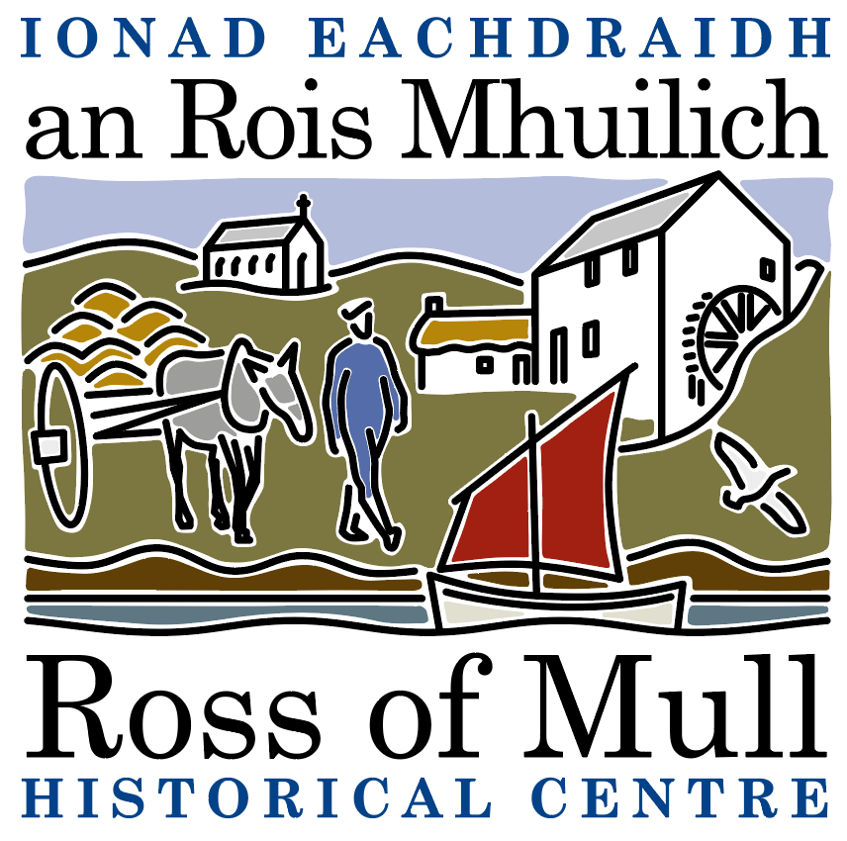

Millbrae Cottage, Bunessan, Eilean Mhuile, ARGYLL, PA67 6DG 01681 700 659 E: enquiries@romhc.org.uk

SCIO No: SC 030873
Ross of Mull Historical Centre

Agenda for 2023 Annual General Meeting

To be held on Saturday 13th January, 2024 at 2.00 pm
at the Ross of Mull Historical Centre, Millbrae Cottage, Bunessan

1. Present

2. Apologies

3. Minutes from the 2023 AGM

4. Trustees Report

5. Approval of Financial Statements

6. Election of Directors
Current Trustees are Anne Baxter, Sue Clare, Alex Fletcher, Judy Gibson, Roger Harvey, Tessa Howell, Jan Sutch Pickard. At the AGM under SCIO, all are required to stand down, but all can be re appointed at this meeting.

7. AOCB

To be followed by ‘The Drove Road – An Historic Journey’ a talk by Donald MacGillivray, aka ‘Donald Drover’.

