Ross of Mull Historical Centre Trustee’s Annual Report
to be presented at the AGM 13th January 2024
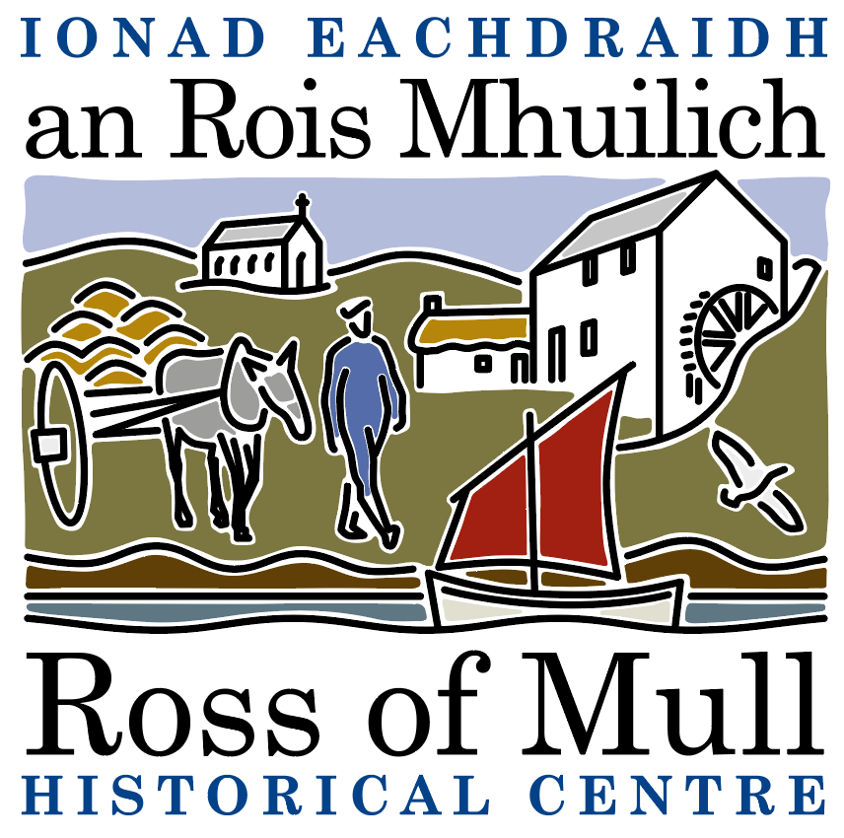

Millbrae Cottage, Bunessan, Eilean Mhuile, ARGYLL, PA67 6DG
01681 700 659 E: enquiries@romhc.org.uk
SCIO No: SC 030873

RoMHC Trustees Annual Report for the year 2022/23
In reporting the work of the Centre, there’s a problem with the ‘time lapse’ effect. Our report is meant to deal with a financial year that ended eight months ago. But in fact, at our last AGM in January 2022, we could not refrain from giving an enthusiastic account of what had happened in the second half of 2021. In other words, we are always catching up with ourselves – and that’s because we are a living organism.
So please accept that some of the things you will read or hear now should perhaps be left for another year to be reported. But why wait?
A high point of the year 2022/23 was in fact artist Mhairi Killin’s talk, which was part of our AGM held in January. She described her recent collaborative project, On Sonorous Seas, which began when a dead whale was stranded on Iona. Using scholarship, film, music, and poetry she explored the impact of military sonar on the ecology of the seas surrounding the Hebrides. That afternoon, Mhairi herself was stranded on Iona by the weather, but was enabled to deliver her talk, slides and all, by Zoom, direct to an audience of about 28 people gathered in the Historical Centre. We’re grateful to Miek Zwamborn and Rutger Emmelkamp of Knockvologan Studies, working with Judy Gibson, for their technical support. This was a ‘first’ for us.
Each year we find ourselves tackling new challenges and learning new skills. The Community Garden has benefited the people of the Ross, as a place to enjoy growing things, pick up vegetables in season from the stall at the gate with its ‘honesty box’ and hold celebrations such as plant swaps and picnics. With the help of SWMID we are learning more about managing this piece of land surrounding the Centre. With that, comes responsibilities – for instance, with people from seniors to toddlers crossing the wooden bridge over the Bunessan River, we have realised that we are responsible for safety and its maintenance. That work is now in hand. We would like to say a big thank you for the donations we have received so far towards the repair of the bridge: £500 grant from MESS , £100 from the Toddler Creative Sessions and a generous individual donation of £50. The bridge repairs will cost close to £2000 so any additional help would be most appreciated. A project to stabilise and possibly develop the ruined Mill, proposed in our last report, has taken longer than we hoped to get under way, but the donation received for a feasibility study will now be well spent.
The painstaking task of cataloguing our archives has been generously undertaken by Andrea Cameron, working with Kirsty our part-time Administrator. We are grateful to the Waterfall Fund for a grant which has enabled us to keep the Centre warm and well lit, and paid for use of computer and internet over the winter. The Trustees are learning to use the new system, and we hope there will be another out-of-season training session for volunteers; the last one on the catalogue system having been much appreciated.
Each time we open our doors to the public we find it hard to predict whether there will be a trickle of day visitors or a flood! The banner on the fence, signage at the gate and now two eye-catching ‘feather’ flags, flying at gate and gable-end (for which we are grateful for a grant from MESS) do make a difference. It is easier to foresee the interest that will be generated by talks such as Eleanor MacDougall’s, early in the season, on Decorative Plant Forms in the West Highland School of Stone-carving. This may seem a niche subject, but we had a full house because of local respect for the speaker; and it was fascinating.
Similarly our theme for the 2023 Bunessan Show was Local Heroes. One of these was Calum Macpherson, miller, carpenter, piper and a key person in the rebuilding of Iona Abbey in the 1940s, 50s and 60s. As well as pictures from our archive we were able to display the kilt suit which he wore when piping, which had come to light, very well preserved, in the loft of a Bunessan village house. Many of those who came to our stand at the Show, had stories to share about him.
Since then we have restarted the oral history /reminiscence sessions called Remembering the Ross. These were discontinued during Covid. But, with a good take up, we hope that they can happen monthly in Creich Hall, on days when the Library is in session there.
Meanwhile, back at the Centre, John Faithful is offering drop-in sessions to help identify pebbles folk have picked up from our beaches. These go under the catchy title of Stone Chat. Our thanks to John and Eleanor and Mhairi for ways they enliven and educate us! And also, though we cannot express it in person now, to Dr Stewart Cameron, author of A History of the Ross of Mull, who died earlier this year. His love of Mull, and his enthusiasm in communicating it, inspired us all. His unique book has sold out, but we hope that a reprint will soon be available.
Among the many others we would like to thank are Christine MacCallum, who, with her daughter, continued Sandy’s work of training the competitors for our annual duck race each Easter Day and launching them down the Bunessan River from the footbridge. She has now retired with honour – and we are looking for a replacement.
Thanks, too, to our volunteers: the Centre could not open without their cheerful involvement. So at this point we repeat a challenge issued last year.
The Centre exists to help research the history of the Ross, preserve the heritage and share its many stories in a lively way. To make the most of our potential we need, not just funds, but people willing to be involved. If you feel inspired to offer even just a few hours as a volunteer, you will be most welcome. We are also looking for those who could commit in the longer term as Trustees – this would be a real contribution to the community of the Ross of Mull.
Jan SP 6.12.23

