Ionad Eachdraidh an Rois Mhuilich
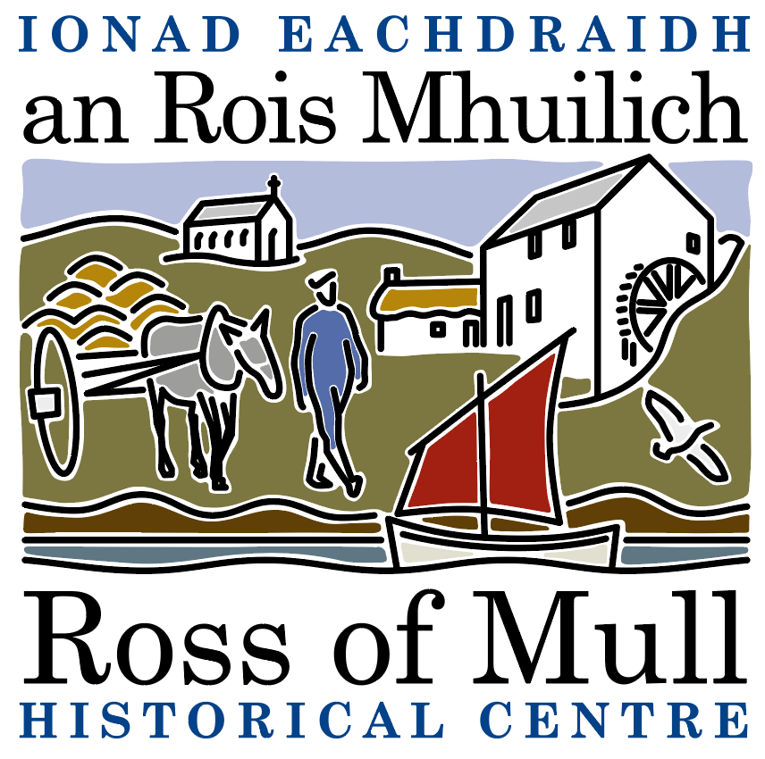

Millbrae Cottage, Bunessan, Eilean Mhuile, ARGYLL, PA67 6DG 01681 700 659 E: enquiries@romhc.org.uk

SCIO No: SC 030873
Ross of Mull Historical Centre
Minutes of 2022 Annual General Meeting

Held on Saturday 14th January, 2023 at 2.00 pm, at the Ross of Mull Historical Centre, Millbrae Cottage, Bunessan

Judy Gibson welcomed all to the meeting.
The formal meeting was preceded (by zoom) by a fascinating presentation by Iona artist Mhairi Killin who talked about her recent collaborative project, On Sonorous Seas, which began when a whale carcass washed ashore on Iona in 2018. It is a story told with the voices of science, art, music and poetry, and it explores the impact of military sonar on the ecology of the seas surrounding the Hebrides.
- Present : Anne Baxter, Ron Blacoe, Shirley Blacoe, Jane Brunton, Sandy Brunton, Nigel Burgess, Rosie Burgess, Sue Clare (minutes), Janet Claxton, Helen Crocher, Rutger Emmelkamp, Alec Fletcher, Judy Gibson (chair), Roger Harvey, Alex James, Margaret Matthew, Anna Mockford, Peter Skinner, Jan Sutch Pickard, Emily Wilkins, Miek Zwamborn.
- Apologies : Rachel Carnegie, John Clare, Jo Currie, Janice Hall, Tessa and Iain Howell.
- Minutes of the 2021 AGM (held by zoom) : These were agreed as an accurate record of the meeting, proposed by Anne Baxter, seconded by Nigel Burgess, all were in favour.
- Trustees Report : Jan Sutch Pickard presented the report, which had been emailed to Members prior to the meeting, and is included here :-

This has been a quiet but creative year. Following Covid closure and continuing restrictions, our re-opening was phased, with half-day opening throughout the 2022 season. However, there was much going on ‘behind the scenes’ and in the grounds of the Centre. The Community Garden continues to be a focus of interest for visitors to the Ross, as well as a setting for activities involving local people of every age, such as a Harvest Celebration and Food Swap, featuring fresh vegetables and fruit, home-made jam and chutneys, followed by delicious food to share.
Over the winter we hope to add another title to our popular series of Walks booklets, as well as continuing to follow up genealogy requests. It is a delight to meet some of our correspondents from Canada, the States or even Australia, when they make a long-planned visit to Mull as part of a family history search, in which we have been able to help.
Two new long-term projects have begun, and are on-going:
Cataloguing our archives and resources
The audit of our archive was completed last year.
A systematic approach, as time allows, has already produced a catalogue of OPRs, censuses, civil registration, statistical accounts, poor law, electoral registers and valuation rolls. The categories of Schools, Agriculture and Fisheries and Churches have also been catalogued. There is more to do, including a challenge to study the many photographs that have been donated, over the years, to identify more people and places. We are grateful for the work being done on this project by Andrea Cameron, assisted by Kirsty Lord.
Bunessan Mill
We have long wanted to do restoration work on the Mill. Recently, we were extremely grateful to receive a very generous donation to enable us to fund a feasibility study, to carry out surveys and inspections and provide recommendations for work to stabilise and conserve, and possibly roof, the Mill building.

Public Events: 2022 saw a number of events, in which the Centre Trustees and Volunteers participated in a practical way, even when it wasn’t our initiative. For instance the Museum was the setting for a fascinating presentation by an Orcadian geneticist working for Edinburgh University, launching a study of the prevalence of Viking Genes in Mull families.
Meanwhile, over several months, SWMID sponsored a project for Scotland’s Year of Stories, focusing on the history of fishing on the Ross. The Centre was identified as a key resource for this, and we worked with Alasdair Satchel, the Mull filmmaker, suggesting contacts and providing visual material. Several people who will be present at the our AGM were interviewed for Cliabh an T- Seanachais – ‘Creel of Stories’. The film had its premiere at Creich Hall in July, and in the autumn there was a screening for pupils of Bunessan School. It can be viewed now on https://www.youtube.com/watch?v=E_O5hbU-0Kc and is well worth watching.
In between these events came the Bunessan Show – the first for two years – and the theme of our display was Sea Stories, reflecting the fishing industry, the many local men who served in the Navy, wrecks, tombstones and the jetties which connected us with a wider world. There was a bit of fun (though sadly only in transcripts) in the storytelling of Donald MacFarlane (Dan Dubh): ‘Innis T’Eile!’ ‘Tell Another One!’
At the Show we also had a large display board telling the story of The Drowning of the Harvesters: ‘Bàthadh nam Buanaichean’. Many who visited our stand were moved by this tragic tale of the 42 migrant workers from the Ross and Iona who were drowned in the Clyde when their sloop was run down by a steam tug. Tom Aitcheson, who researched the story and documented it, organised a commemoration at Creich Hall on 10 August, the 200th Anniversary of the disaster, That display board can now be studied in the Centre and there is discussion about a more permanent memorial at Gourock. Our thanks to Tom Aitchison for his commitment to campaigning for justice for the ‘Harvesters’.
Membership The Trustees have agreed a clearer presentation and a small increase in subscriptions, and are now awaiting agreement from Members at the AGM.

And finally, an invitation ... The Centre exists to help research the history of the Ross, preserve the heritage and share its many stories in a lively way. To make the most of our potential we need not just funds but people willing to be involved. If you feel inspired to offer even just a few hours as a volunteer, you will be most welcome. We are also looking for those who could commit in the longer term as Trustees – this would be a real contribution to the community of the Ross of Mull.

- Approval of Financial Statements : Roger Harvey talked through the accounts. £10,000 of the donations amount has been given by an American donor to be used for the Mill Project. Without this there would be a loss of about £2,500 for the year, costs have gone up this year. Practically all sales have been on line for this year, thankyou to Kirsty. Approval was proposed by Sue Clare, seconded by Anne Baxter.
- Membership and Subscriptions : an increase in membership fees is proposed, from £7 to £10, £5 for students / OAPs, this needs to be approved at the AGM - approval was proposed by Rosie Burgess, seconded by Sandy Brunton, all were in favour of the fee change. Membership will now run from January to December in future. Members will need to complete new membership forms, available at this meeting. It is helpful if members are able to set up as standing order, and gift aid their fee if eligible to do so.
- Election of Trustees : Current trustees are are Anne Baxter, Sue Clare, Judy Gibson, Roger Harvey, Tessa Howell and Jan Sutch Pickard. At the AGM under SCIO, all are required to stand down, but all can be reappointed at this meeting. All the current trustees are prepared to stand again, reappointment of all was proposed by Ron Blacoe, seconded by Nigel Burgess. Additional trustees would be very welcome.
8. AOCB: None raised.

